Date: January 8, 2019

From: Team 5 -

Victor

Antonio

David

German

To: GA Tech Bootcamp TA Team

**Subject: Project 1 Proposal: E-Commerce site**

Dear TA Team,

We are pleased to submit to you the following proposal for our first project at the Coding Bootcamp.

We have considered to present to you an E-commerce site for My Little Princess Dress, from herein the ‘Company’. This 5 year-old family-owned company sells dresses for costume parties, First Communion and Baptism to the local market.

Company requires a page to commercialize its products.

We will design the application with the following main features:

* Home/Welcome Page
* Product Page
* Cart page
* Success purchase page
* Who we are

**Description of the Web Site**

The **Welcome Page** will present a simple mosaic with pictures of some of the dresses in a slide-show motion, new library will be considered and will have a menu bar with the “Home”, “Product”, “Contact”, “Who we are”.

In the **Product Page** we will present details on three basic products (dresses): Photos, Inventory, and Prices. Inventory information and prices will be stored into the Firebase database.

The Product Page will also allow the customer to select the product and buy it. We will use two APIs: 1) USPS API to validate customer address and 2) the Paypal API with a ‘sand box’ account to simulate the purchase of the product. We will consider the following Use Cases:

a. Successful transaction

b. Rejected transaction

c. Canceled transaction

Any other scenario will be out of the scope at this time.

If time allows it, we will consider to include the API for taxes and shipping costs. It will be also out of scope at this initial stage.

Finally, at the **Who we are** page we will present a basic text with a brief history of the company that will result appealing to the general public.

In the following sections you will find the description of our product and service together with the implementation strategy, compliance to the coding requirements, functional requirements, and Use Cases.

We appreciate once more your consideration to our proposal. Please address any question or comment you may have to our attention.

Sincerely

Team 5:

Victor

Antonio

David

German

# Contents

1. Contents 3

2. Implementation Strategy 4

3. Coding Requirements Compliance 4

4. Nice-To-Haves Compliance 5

5. Coding Standards 5

6. Functional Requirements 5

6.1. Overall Look 5

6.2. Home Page 6

6.3. Product Page 6

6.4. “Who we are” Page 6

7. Product Page Use Cases 7

7.1. Use Case 1 – Successful Transaction 7

7.2. Use Case 2 – Invalid Address 7

7.3. Use Case 3 – Reject Transaction 8

7.4. Use Case 4 – Cancel (Confirm Buy, Paypal, Address form) 8

**Document Version**

|  |  |  |
| --- | --- | --- |
| Version | Description | Responsible |
| 1.0 | Original version | German Garcia |
|  |  |  |
|  |  |  |

# Implementation Strategy

To deliver this Project 1, Team 5 decided to implement the following strategy:

1. List the functional requirements based on the business description (the presentation page)
2. Design the main Use Cases for the product page, which consist on the interactions with the APIs and Firebase
3. Divide the work among the members of the team.

We will divide the work into the following areas and main responsible.

* Design of pages - overall look
* Main responsible - Victor
* New technology (Bootstrap, picture handling)
* Fonts, Colors, Forms
* API connectivity/interaction
* Paypal API – Main responsible: Antonio
* USPS API for address validation – Main responsible: German
* Use Cases
* Firebase
* Main responsible – David

# Coding Requirements Compliance

|  |  |  |  |
| --- | --- | --- | --- |
| 1 | Must Use two APIs | Compliant | We will use 2 APIs:   1. USPS API to verify customers address 2. PayPal with sand box account to perform transaction |
| 2 | Must Use Ajax to pull data | Compliant | We will use AJAX to get the data from the APIs |
| 3 | Must utilize at least one new library or technology that we haven’t discussed | Compliant | The Photo presentation will use a new library to create the slide shows and the photo presentation |
| 4 | Musts have a polished front end | Compliant | We will use bootstrap to create friendly elements (colors, paragraphs, fonts)  We are considering the target audience for the design (Mom’s and girls) t |
| 5 | Must meet good quality coding standards | Compliant | We have set the following standards:   * Indentation with tab character * Variable naming convention: * Function naming convention * File naming convention |
| 6 | Must not use alerts, confirms, or prompts | Compliant | We are not using any of the mentioned elements |
| 7 | Must have some sort of repeating element (table, columns, etc.) | Compliant | We are repeating the navigation bar, the footer, and the header. |
| 8 | Must use Bootstrap or Alternative CSS Framework | Compliant | We will use Bootstrap |
| 9 | Must be Deployed | Compliant | We will deploy at Github page |
| 10 | Must have User Input Validation | Compliant | We will validate characters in the forms we will use (alphanumeric, special characters, numeric – prices) |

# Nice-To-Haves Compliance

|  |  |  |  |
| --- | --- | --- | --- |
| 1 | Utilize Firebase for Persistent Data Storage | Compliant | We will use Firebase to store product information |
| 2 | Mobile Responsive | Compliant | We will use the features in Bootstrap to make it mobile responsive |
| 3 | Use an alternative CSS framework | Partially Compliant | Besides Bootstrap, we will create our own CSS style file. |

# Coding Standards

|  |  |  |  |
| --- | --- | --- | --- |
| 1 | Variable naming convention |  | Global Variable:  gbl_variableName  Local Variable:  localVariableName |
| 2 | Function naming convention |  | FunctionName |
| 3 | File naming convention |  | index.html – Home/landing page  products.html – product page  about.html – about/”who we are” page  cart.html – cart page  success.html – success transaction page  style.css – css page if needed  app.js – java script page |

# Functional Requirements

## Overall Look

|  |  |
| --- | --- |
| 8.1.1 | Overall look should focus on the following customer profile:   1. Women, mainly mothers of 1 – 12 year old girls 2. 1 – 12 year old girls |
| 8.1.2 | Make colors, fonts thinking on customer profile |
| 8.1.3 | All pages shall show the navigation bar with the following Menu options with the attached actions:   * 1. Home – return to the home page   2. Product – to the product page   3. Who we are – go to the ‘about.html’ page |

## Home Page

|  |  |
| --- | --- |
| 8.2.1 | Home Page shall show the picture provided as part of the header |
| 8.2.2 | Home Page shall show the pictures of the products provided on an animated fashion (i.e. slide show) |

## Product Page

|  |  |
| --- | --- |
| 8.3.1 | Product Web Page shall show the product pictures in a friendly transition. |
| 8.3.2 | Each product shall have a description of the product |
| 8.3.3 | Each product shall have the model #, sizes available, and inventory (number of dresses available)   * On this initial phase, do not provide number of dresses per size, per model. |
| 8.3.4 | Customer shall be able to click on each photo to open the details |
| 8.3.5 | When opening the photo, the customer shall be able to open buy the product   1. On this initial phase, do not show more than one picture per product. 2. When requiring buying the product, customer shall be able to add its address    1. Address shall be validated with the USPS 3. Once the address gets validated, the customer shall be able to buy the product by clicking on the “Buy” button 4. As a result of the procurement transaction, the page shall indicate if:    1. Transaction was successful in a success page, provide an option to return to the product page    2. Transaction was rejected in a rejected page – no alerts, no prompts, then return to the product page    3. Transaction was canceled – return to the product page. |

## “Who we are” Page

|  |  |
| --- | --- |
| 8.4.1 | Who we are page shall present the history provided by the Company |
| 8.4.2 | Who we are page shall show the picture provided by the Company. |

# Product Page Use Cases

## Use Case 1 – Successful Transaction

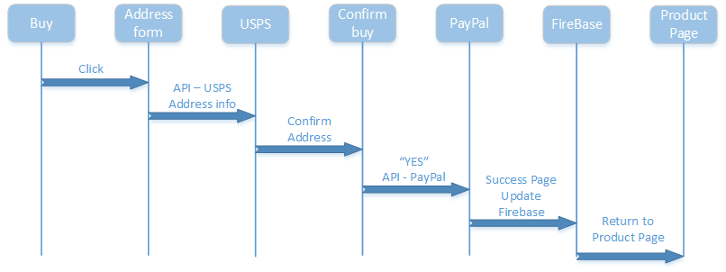

## Use Case 2 – Invalid Address

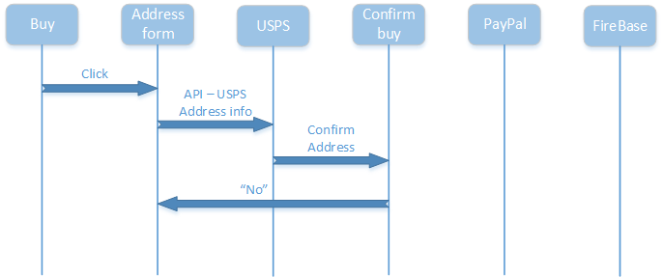

## Use Case 3 – Reject Transaction

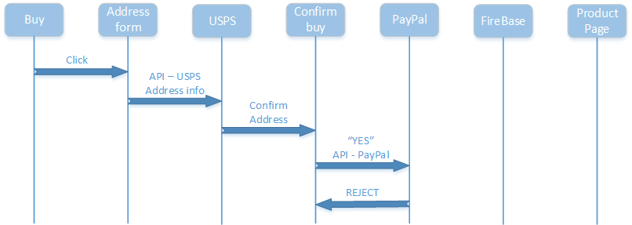

## Use Case 4 – Cancel (Confirm Buy, Paypal, Address form)

